**Posting in ledger**

When we click on create in multiple ledgers we can choose the group and start to post different accounts in respective accounts heads.

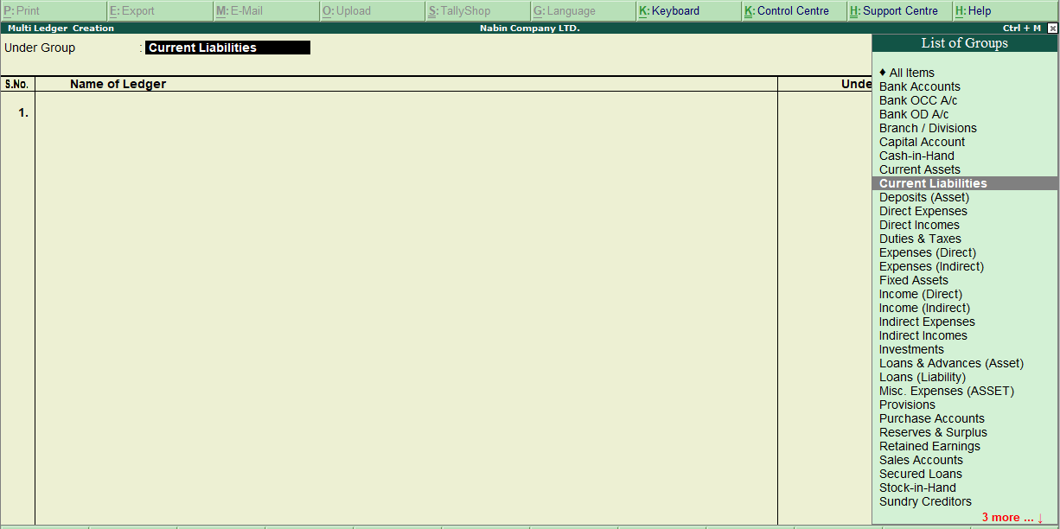

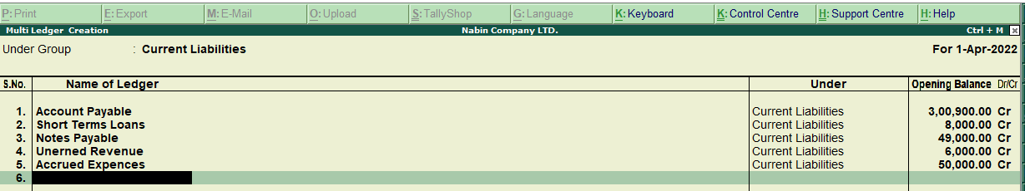

**Trial balance**

after recording the transaction in journals, ledger, or in a subsidiary book it is necessary to verify whether all the entries in the book of the accounts are correctly made. For this, a list of debit and credit totals or balances of all ledger accounts is prepared on a particular date called a ‘Trial Balance’. It includes asset, liability, equity, revenue, expense, gain, and loss account. The trial balance is run as part of the month-end closing process.

To open the trial balance in tally click on the display option on the gateway of tally and then click on the trial balance.

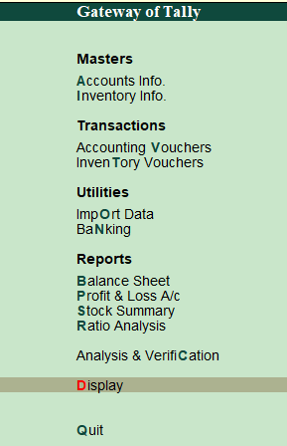 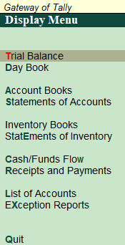

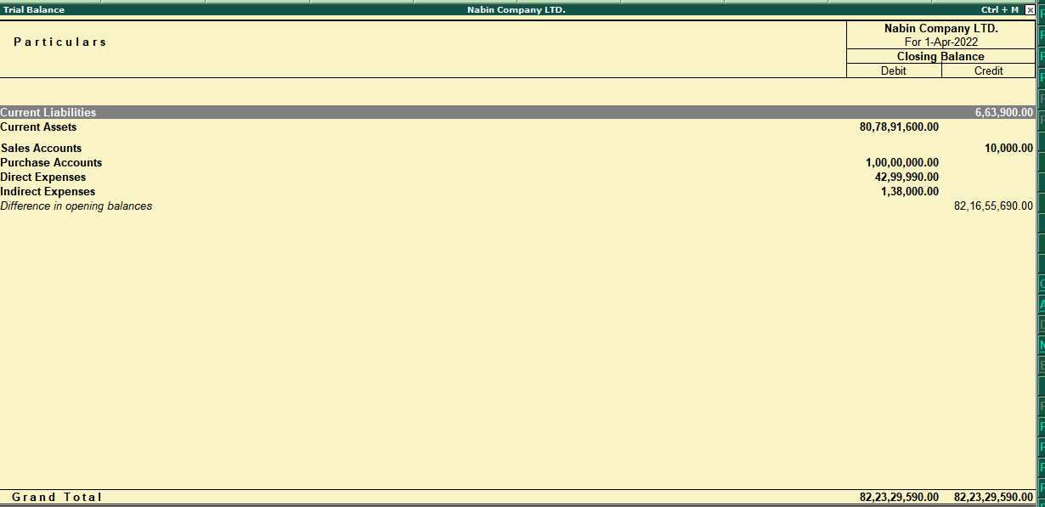

**Trading account**

A trading account is an account that is prepared for ascertaining the overall result of trading i.e. buying and selling of goods. It is an investment account. It is used to determine gross loss or gross profit.

**ledger posting on the trading account**

ledger posting of treading account on debit side

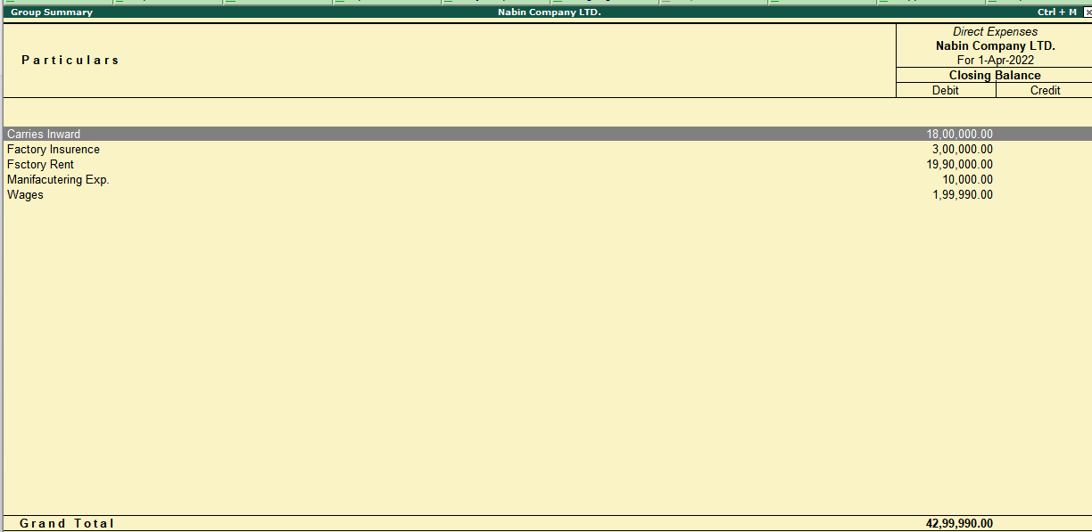

Ledger posting of trading account on credit side

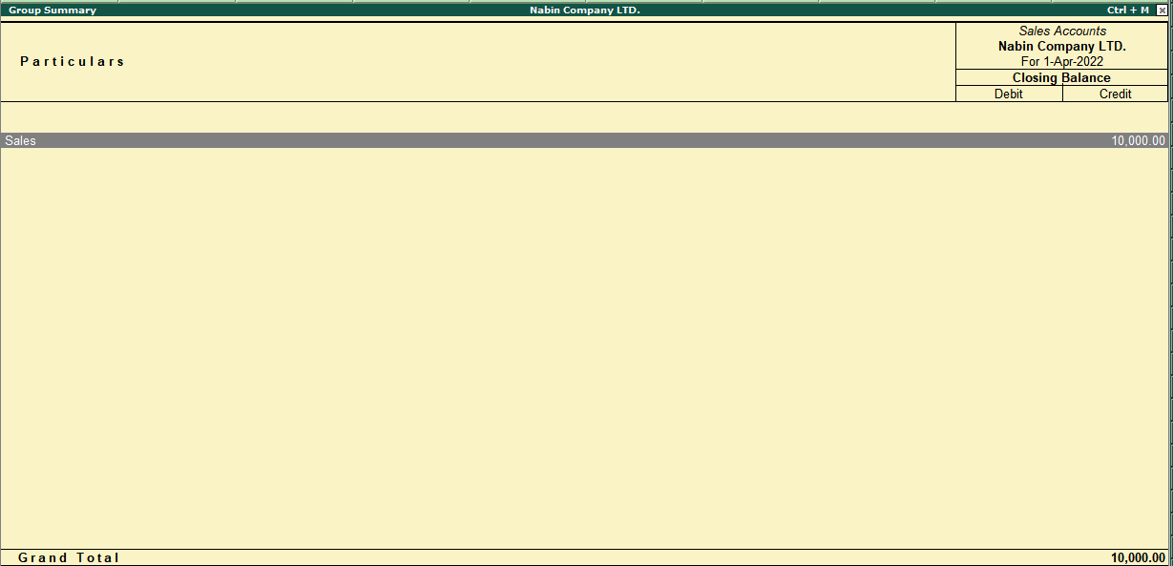

**Profit and loss account (P/L)**

A profit and loss account is a nominal account having debit and credit sides. Only indirect expenses, indirect incomes, or indirect revenues are considered in it. It is prepared to find net loss and net profit.

Posting in debit side

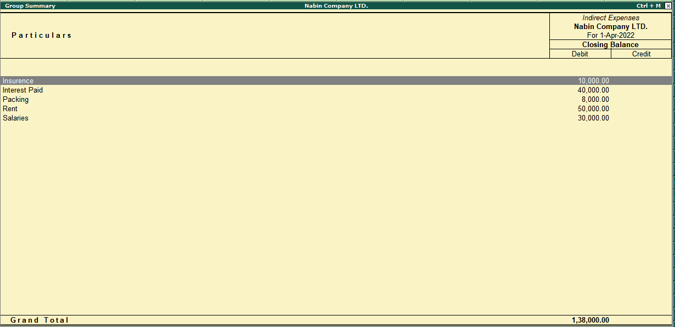

Posting in credit side

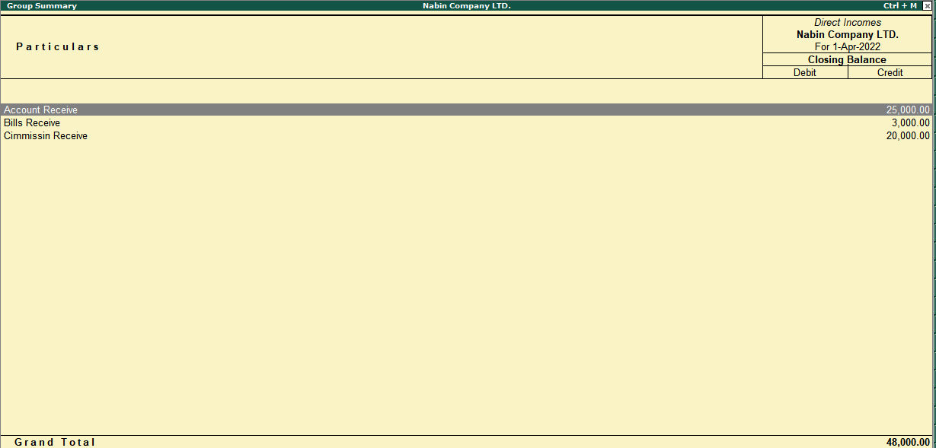

We can open the profit and loss account by clicking on profit and loss A/c in the gateway of Tally.

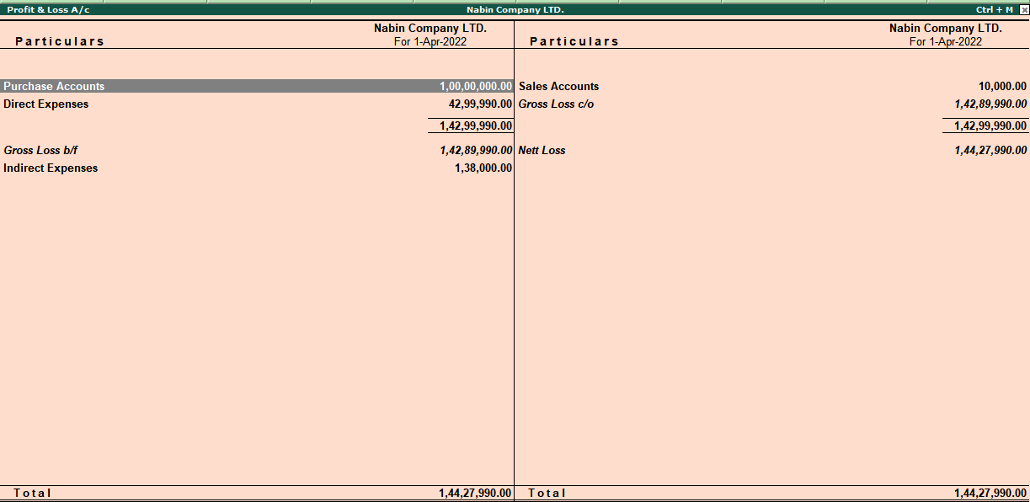 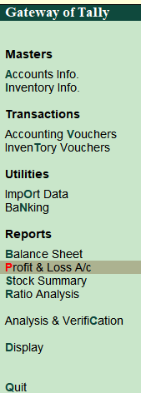

**Balance sheet**

A balance sheet is a financial statement that reports a company's financial position. This report shows the balance between the assets and liabilities of a firm.

Posting on the balance sheet

Posting on the assets side

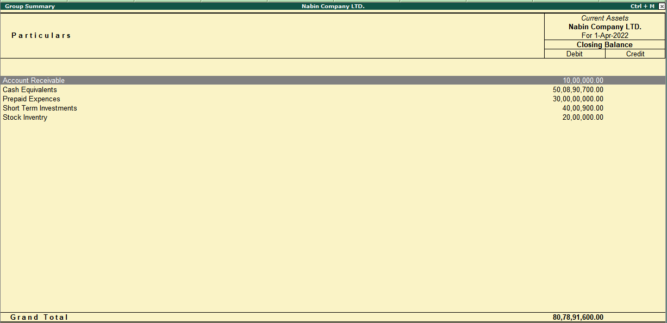

Posting on liabilities sides

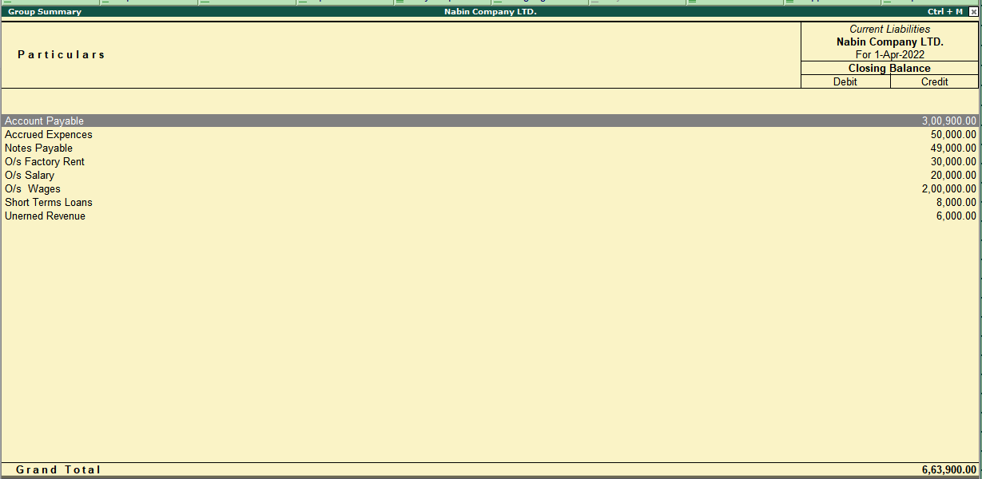

To go balance sheet click on the balance sheet option available in the gateway of Tally.

